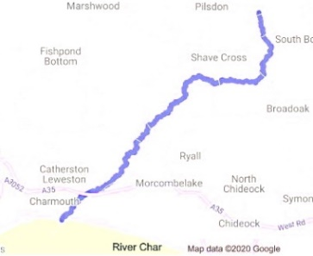
A Broccoli Runs Through It

At 10.4 miles long, the River Char is far from being a record-breaker. The Nile is about 400 times longer and the Danube about 170 times longer. Even the humble Axe is twice as long.
But our idea of a river as a snaking line with a fixed length is as misleading as thinking of a human being or buttercup or country as a detached and autonomous ‘thing’.
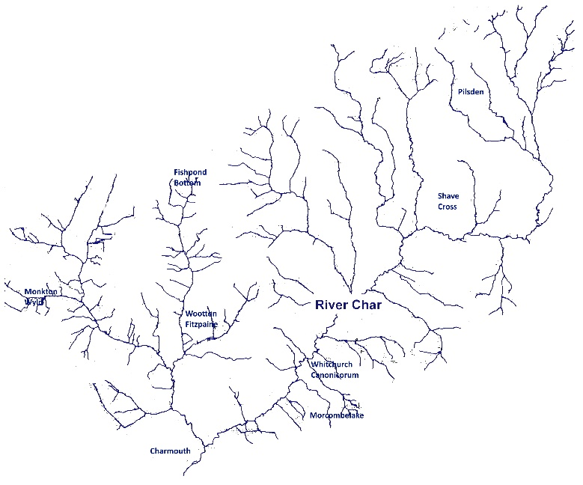
In fact, a river looks less like a snake and more like the blood vessels in a human lung, or a piece of broccoli. Once you factor in the tributaries and streams and ditches and drains that make up the River Char Catchment (far more than appear on even this next map) you have hundreds of miles of water. And, if you walk the footpaths near the river in winter, you find that almost the whole marshy landscape of the Marshwood Vale has become one with the river. There is water everywhere, waiting to find its way into the Char and out to sea – a reminder that the river (like each of us) is a complex ecosystem, intricately entangled in its surroundings.
Looking at the broccoli map, another thing becomes clear. The River Char doesn’t just run through a handful of farms – rather, we almost all live ‘amongst’ it. Few of us can be far from a ditch or drain running into one of its tributaries. That means we’re all involved in the health of the river.
A survey by the Environment Agency in 2014 showed the river’s overall status was ‘Moderate’ (the middle of 5 classifications ranging from ‘High’ to ‘Bad’), but ‘Poor’ in one water quality category. Since then, there have been pollution incidents at the mouth of the river, with raised levels of E. coli and other dangerous bacteria. The river has also suffered from declining biodiversity, increasing agricultural run-off and slurry, mud from roads and land use practices, waste from overflowing septic tanks, overgrown bankside vegetation and algal blooms coupled with high levels of flooding.
For most of their journey to the sea, the River Char and its tributaries flow through the parishes of Wootton and Whitchurch. So, in autumn 2019, Char Valley Parish Council (which includes these parishes) met members of the Dorset Area of Outstanding Natural Beauty (AONB) and Dorset Wildlife Trust (DWT) teams to discuss how start to make changes and improvements.
This followed a successful community project led by the same teams on the River Asker. At their suggestion, we applied for funding for our own River Char Community Project and we heard in December that we had received a full grant of £1,350 from the Dorset AONB 60th Anniversary Fund and the National Lottery Heritage Fund. Our Parish Council will contribute a further £750 in cash and councillors time.
In Phase 1 of this Community Project (to be completed by October 2020), we will use the money to pay for a snapshot study of the River Char to get a picture of the health of the river, identify problems and draw up an improvement plan. In Phase 2 (which will need significantly more funding) we will implement the plan, which is likely to involve working with experts, volunteers and residents to do some of the following:
- raise awareness of the issues facing the river and keep people up to date about progress
- teach residents to undertake river monitoring and fish surveys
- involve local school children in exploring the history and zoology of the river
- control invasive species (e.g. clear Himalayan Balsam)
- use natural measures to manage flooding (e.g. gully blocking and installing woody debris dams) and reduce erosion (e.g. installing fencing, cattle drinking bays and cattle crossing points)
- clear some riverside tree cover to enhance the habitat for plants, insects and other wildlife
- remove/bypass barriers to help fish populations in the river
- help neighbouring landowners to install silt traps and plant hedges to reduce run-off.
Phase 2 will look at ways to help landowners and residents make improvements and seek funding to enable them to do so. But that’s for the future. For now, we aim to present the Survey results at a public meeting in the autumn.

