Our Mission 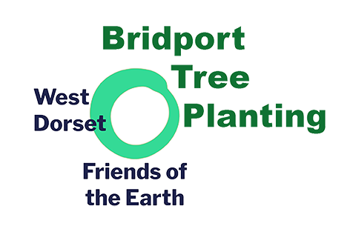

Formed in autumn 2019, Bridport Tree Planting promotes and enables the planting of trees in Bridport and the surrounding area. This project runs alongside Friends of the Earth’s campaign to double tree cover in the UK.

Why we need more trees.

We need more trees to counteract the increase in greenhouse gas emissions, to increase biodiversity and wildlife, to provide shade and cooling, and to protect against flooding. While our motivation often comes from our love and respect for trees, increased tree cover is essential if we are going to come close to keeping our promises to maintain a habitable climate.

We work closely with Bridport Town Council to map, develop and maintain the local tree stock.
In order to find suitable sites for planting, we aim to foster relationships with parish councils, schools, housing associations, farmers and interested members of the public. We can help with decisions on the most appropriate native species for each location and help put in place a careful maintenance programme; both necessary to aid successful establishment. Natural regeneration is also greatly valued and we facilitate this wherever possible.

We are conscious of the need for community involvement and will continue to organise mass plantings, and gatherings like More Trees Please, our annual profile-raising event. It is our ambition to work with schools, both with planting their campuses but also with practical education about trees and their importance.

Bridport Tree Planting manage a modest tree nursery at Riverside Gardens on land borrowed from the Town Council. Here we can hold saplings prior to planting and grow on trees bought in or donated to us. We source our tree stock from several conservation organisations, tree nurseries and accept young trees from the public if they are suitable for our purposes.

What we offer.

Our knowledge, encouragement, contacts (suppliers and experts) and in some cases practical support to anyone wishing to extend our woodlands. This includes schools, community groups, parish councils and private landowners. We have a regular newsletter, which is emailed to supporters numbering now more than 100. Joining our mailing list is free and carries no obligation.
Young saplings and guards are available on a donation basis.

Want to become involved? Contact joe@thehacketts.uk

June 2020

